Objectives:

* Create a TREE VIEW, database, and table, enter rows, display the rows, and using SQL Lite Studio

**There are 5 print screens each worth 20%.**

**Project #1 (Using sqlite3 to create a database, table, enter rows and display the rows).**

**Project #2**

**Challenge Exercise #1 (Complete the following below).**

**#1 Print screen the results below here, the table must show all the rows for the products table.**

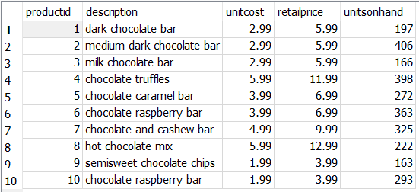

**Project #3 (Creating Relations between TWO Tables) using the inner join, where rows are referenced.**

**Challenge Exercise #2:** continuing from challenge exercise #1, create the following table below and establish a relationship between the **Warehouse** and Products Table.

Table Name: Warehouse

|  |  |  |
| --- | --- | --- |
| WarehouseID | ProductID (make this column a foreign key that will reference the ProductID for the Products table) | StorageLocation |
| 100 | 1 | South |
| 200 | 2 | South |
| 300 | 3 | East |
| 400 | 4 | West |
| 500 | 5 | West |
| 600 | 6 | MidWest |
| 700 | 7 | MidWest |
| 800 | 8 | East |
| 900 | 9 | East |
| 1000 | 10 | West |

Then extract the columns and rows from the two tables.

**#2 Print screen the output of the tables below here**

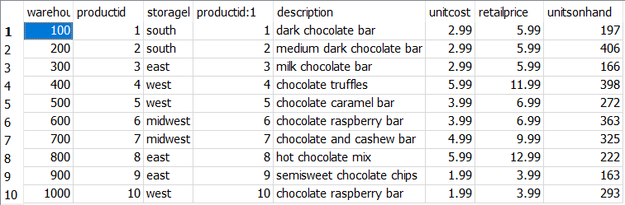

**Project #4 (Patients ERD)**

Create a database and label it as **PatientsDB** then open the SQL editor and complete the ERD diagram below: Be sure to add primary keys and foreign keys to the proper tables. Enter the data as shown in the diagram below.

Then using Python point to the database and extract the Patients, Prescriptions, and Doctors’ tables.

**#3 Print screen the output of the three tables below here.**

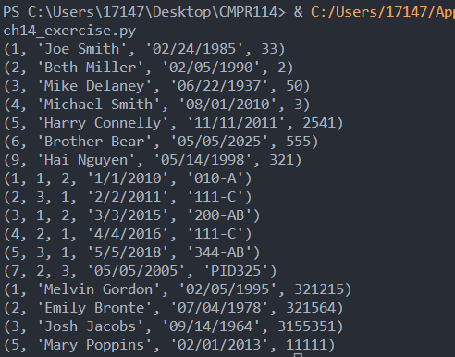

Join the three tables into one query and print screen it below.

**#4 Print screen the joining of the three tables below here.**

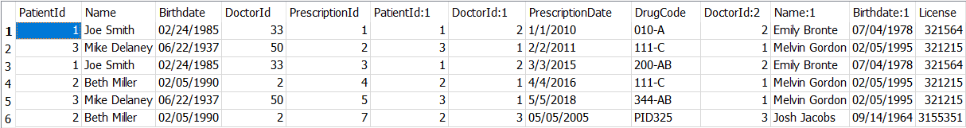

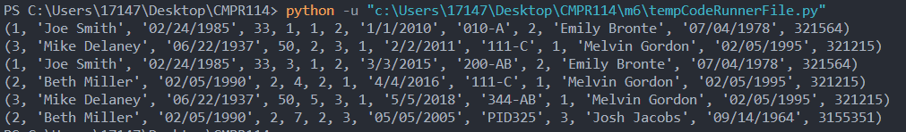

**Project #5**

This program will use a GRID VIEW to display the results.

**Challenge Exercise #3:** Continuing from project #5, add the Address, City, and State, with the Zip code.

**#5 Print screen the results below here. (Be sure to add some data).**

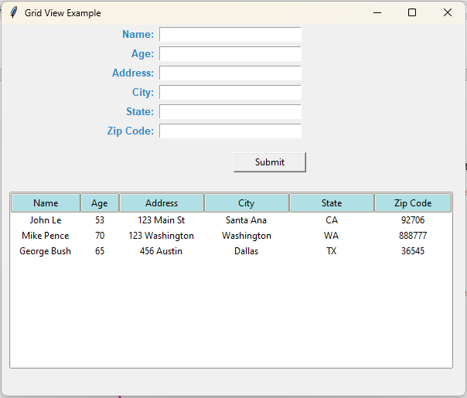

**Submit this document to the Module 6 Class Exercise.**